WORKSHOPS at Lofts Farm Studio
Autumn 2026
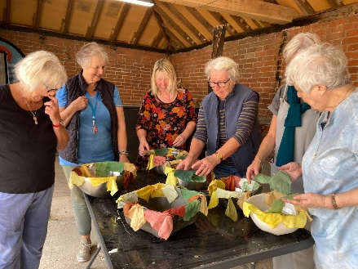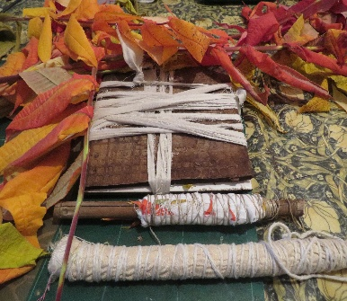
INTRODUCTION TO COLOURED DYES
Tues. November 10th, 10am to 12.30
Saturday October 31st, 2pm to 4.30pm
£60 limited to 6 places
INTRODUCTION BOTANICAL PRINTING
Tues. October 27th, 10am to 12.30pm
Saturday October 24th, 2pm to 4.30pm
£60 limited to 6 places
JOURNEY INTO BLUE WITH INDIGO
Tuesday November 17th, Saturday Nov. 21st
10am to 12.30am £60 limited to 5 places
Also Dye club meets 10 am monthly. The first Tuesday
and last Saturday of the month. £25 per session
Booking - colournaturally.co.uk
email edwina@colournaturally.co.uk

